**Test Summary Report**

Report date: June 19, 2024

**1. Purpose**

This document describes the various steps to test a Shopping List mobile app on an Android emulator.

**2. Application overview**

“Shopping List” is a mobile application designed for conveniently creating and managing shopping lists. Main aspects and features of this application:

-List Creation: Shopping List allows users to easily create different shopping lists for different purposes, such as shopping for the week, going to the store, preparing for a party, etc. Users can add products and items to the list manually or using voice commands

-Purchase management: The application provides the ability to mark products as purchased or remove them from the list after purchase. This helps users keep track of what has already been purchased and what is left on the list.

-Notifications and Reminders: The app can send notifications about upcoming purchases or reminders to re-order certain items. This is especially useful for those who want to keep track of inventory and plan purchases in advance.

There are several modules, such as: Installing an application, Running an application, Creating a task, Changing and deleting a task, Checking for interruptions, Additional checks.

**3. Scope of testing**

The following modules have been tested: Installing an application, Launching an application, Creating a task, Changing and deleting a task, Checking for interruptions.

a) By volume

Functional testing of the following modules is included in the scope of testing.

• Installing/launching the application

• Create a task,

• Changing and deleting a task

b) Goes beyond

No performance testing has been conducted for this application.

c) Items not verified

Checking connection with the third-party system "Central

repository system" was not tested because the connection could not be ensured.

installed due to some technical limitations. This can be checked during

UAT (User Acceptance Testing) where connectivity is available or can be established.

**4. Metrics**

d) No. of test cases planned vs executed

e) No. of test cases passed/failed

|  |  |  |  |
| --- | --- | --- | --- |
| Test cases planned | Test cases executed | TCs Pass | Tcs Failed |
| 45 | 30 | 22 | 9 |

**Test Cases Pass vs Fail**

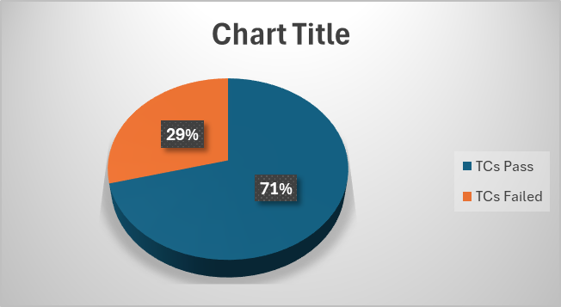

**f)**

**No of defects identified and their Status & Severity**

|  |  |  |  |  |  |
| --- | --- | --- | --- | --- | --- |
|  | Critical | Major | Medium | Cosmetic | Total |
| Closed | 1 | 3 | 5 |  | 9 |
| Open |  |  |  | 3 | 3 |
|  |  |  |  |  | 12 |

**Defects Severity & Status**

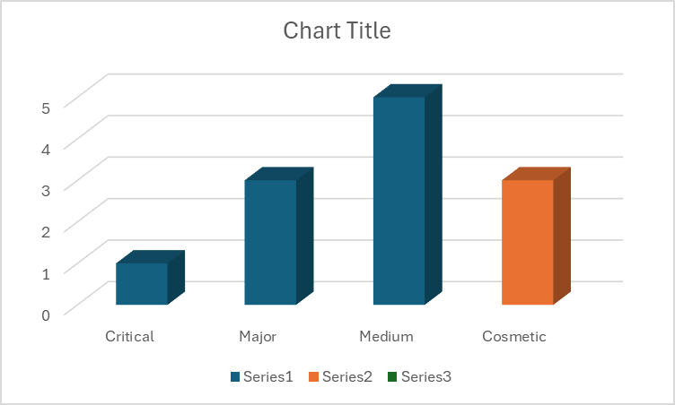

**g) Defects distribution – module wise**

|  |  |  |  |  |  |  |
| --- | --- | --- | --- | --- | --- | --- |
|  | **Installing an application** | **Running an application** | **Creating a task** | **Changing and deleting a task** | **Checking for interruptions** | **Total** |
| **Critical** | - | - | 1 |  | - | **1** |
| **Major** | - | - | 1 | 2 | - | **3** |
| **Medium** | - | - | 1 | 4 | - | **5** |
| **Cosmetic** | - | - | 2 | 1 | - | **3** |
| **Total-->** | **0** | **0** | **5** | **7** | **0** | **12** |

**Defects Distribution-Module Wise**

**5. Types of tests performed**

a) Functional testing

Functional testing aims to verify whether the application meets the functional requirements and user expectations.

Checking the basic functions of the application.

Checking navigation, interaction with interface elements, and correct data display.

Testing data validation and error handling.

Verifies that the application meets the functional requirements described in the product specification.

b) System integration testing

• It is testing performed on the application under test to

Make sure the entire application works as required. • Critical business scenarios were tested to ensure that important

The functionality of the application works as intended without any

errors.

c) Mobile testing

Testing installation and launch of the application.

Checking the application for interrupts.

**6. Test Environment & Tools**

|  |  |
| --- | --- |
| Application URL | https://appdistribution.firebase.google.com/pub/i/ef0e71eeb4f2d6a5 |
| Environment | Android Studio Jellyfish | 2023.3.1 |
|  | Windows 11 Pro 21H2, System type 64-bit operating system, x64-based processor, Installed Ram 8.00 GB |
| Emulation | Pixel 6 API, Android 12 |

**Conclusion**

The testing revealed several tests that will require improvement. However, the results will improve the quality of the product and increase its reliability.